Lab Exercises

Classes and Object(Assignment 1)

1. Create a class called Emp with data members empno, empname, designation, dept and salary and methods as readEmpData() (to read values to data members) and displayEmpData() (to display data members values to the screen) create an employee instance and display its information.

import java.util.Scanner; // Import the Scanner class for taking user input

public class Emp {

    int empno; // Variable to store employee number

    String empname; // Variable to store employee name

    String designation; // Variable to store employee designation

    String dept; // Variable to store employee department

    int salary; // Variable to store employee salary

    // Method to read employee data from user input

    public void readEmpData() {

        Scanner sc = new Scanner(System.in); // Create a Scanner object for input

        System.out.println("Enter Employee Number: ");

        empno = sc.nextInt(); // Read integer input for employee number

        // Consume the newline character left by nextInt()

        sc.nextLine();

        System.out.println("Enter Employee Name: ");

        empname = sc.next(); // Read string input for employee name

        System.out.println("Enter Designation: ");

        designation = sc.next(); // Read string input for employee designation

        System.out.println("Enter Department: ");

        dept = sc.next(); // Read string input for employee department

        System.out.println("Enter Salary: ");

        salary = sc.nextInt(); // Read integer input for employee salary

        sc.close(); // Close the Scanner object to prevent resource leaks

    }

    // Method to display employee data

    public void displayEmpData() {

        System.out.println("Employee Number: " + empno); // Display employee number

        System.out.println("Employee Name: " + empname); // Display employee name

        System.out.println("Designation: " + designation); // Display employee designation

        System.out.println("Department: " + dept); // Display employee department

        System.out.println("Salary: " + salary); // Display employee salary

    }

}

    // Method to display employee data

    public void displayEmpData() {

        System.out.println("Employee Number: " + empno); // Display employee number

        System.out.println("Employee Name: " + empname); // Display employee name

        System.out.println("Designation: " + designation); // Display employee designation

        System.out.println("Department: " + dept); // Display employee department

        System.out.println("Salary: " + salary); // Display employee salary

    }

}

public class TestEmp {

    public static void main(String[] args) {

        // Create an instance of the Emp class

        Emp employee = new Emp();

        // Call the method to read employee data from user input

        employee.readEmpData();

        // Call the method to display the employee data

        employee.displayEmpData();

    }

}

Output

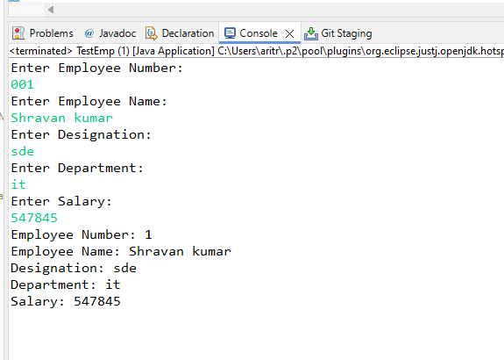

1. Create a class Electricity bill with data members as customer number, customer name, units consumed and methods as follows:

1. readData() - to read the values of data members.

2. showData - to display the customer details

3. computeBill() - to calculate and return electricity charges to be paid. calculate the bill as specified below

number of units charges

< = 100 Rs.1.20

for the next 200 units Rs. 2.00

for the next 300 units Rs. 3.00

for more Rs. 5.00

ex: input = 320 units output = 100*1.20 +200*2.00+20*3.00 = Rs. 580

Read customer object values, calculate electricity bill and display the values.

import java.util.Scanner; // Import the Scanner class for taking user input

public class ElectricityBill {

    int customerNumber; // Variable to store customer number

    String customerName; // Variable to store customer name

    int unitsConsumed; // Variable to store the number of units consumed

    // Method to read customer data from user input

    public void readData() {

        Scanner s = new Scanner(System.in); // Create a Scanner object for input

        // Prompt and read customer number

        System.out.println("Enter Customer Number: ");

        customerNumber = s.nextInt();

        // Consume the newline character left by nextInt()

        s.nextLine();

        // Prompt and read customer name

        System.out.println("Enter Customer Name: ");

        customerName = s.nextLine();

        // Prompt and read the number of units consumed

        System.out.println("Enter the number of units you have consumed: ");

        unitsConsumed = s.nextInt();

        // Close the Scanner object to prevent resource leaks

        s.close();

    }

    // Method to display customer data

    public void showData() {

        // Display customer number

        System.out.println("Customer Number: " + customerNumber);

        // Display customer name

        System.out.println("Customer Name: " + customerName);

        // Display the number of units consumed

        System.out.println("Units Consumed: " + unitsConsumed);

    }

    // Method to compute the electricity bill based on units consumed

    public double computeBill() {

        double bill; // Variable to store the computed bill amount

        // Calculate the bill amount based on different slabs

        if (unitsConsumed <= 100) {

            bill = unitsConsumed * 1.20; // First 100 units at $1.20 per unit

        } else if (unitsConsumed <= 300) {

            bill = 100 * 1.20 + (unitsConsumed - 100) * 2.00; // Next 200 units at $2.00 per unit

        } else if (unitsConsumed <= 600) {

            bill = (100 * 1.20) + (200 * 2.00) + (unitsConsumed - 300) * 3.00; // Next 300 units at $3.00 per unit

        } else {

            bill = (100 * 1.20) + (200 * 2.00) + (300 * 3.00) + (unitsConsumed - 600) * 5.00; // Above 600 units at $5.00 per unit

        }

        // Return the computed bill amount

        return bill;

    }

}

public class ElectricityBillMain {

    public static void main(String[] args) {

        // Create an instance of the ElectricityBill class

        ElectricityBill eb = new ElectricityBill();

        // Call the method to read customer data from user input

        eb.readData();

        // Call the method to display customer data

        eb.showData();

        // Call the method to compute the electricity bill and store the result

        double bill = eb.computeBill();

        // Display the computed electricity bill

        System.out.println("Your Electricity Bill: " + bill);

    }

}

**Output**

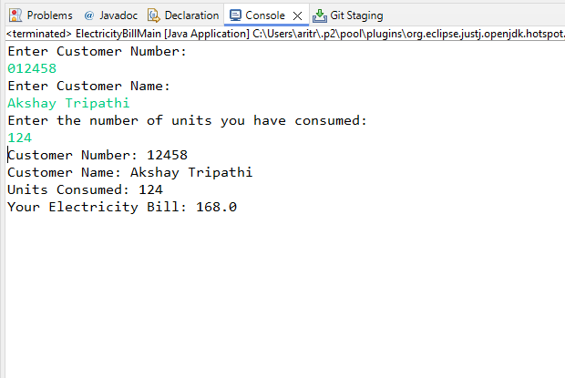

3. Write a Java program to create Student class with member variable as id, name, mark and result. Use method to initialize the value of name, id and marks. Write a member function to find the result and display the student details with result.

import java.util.Scanner;  // Import the Scanner class for taking user input

public class Student {

    static int id;  // Static variable to store student ID

    static String name;  // Static variable to store student name

    static int mark;  // Static variable to store student mark

    String result;  // Instance variable to store result (Pass/Fail)

    // Method to read student details from user input

    public void readDetails() {

        Scanner sc = new Scanner(System.in);  // Create a Scanner object for input

        // Prompt and read student ID

        System.out.println("Enter Student's Id: ");

        id = sc.nextInt();

        // Consume the newline character left by nextInt()

        sc.nextLine();

        // Prompt and read student name

        System.out.println("Enter Student's Name: ");

        name = sc.nextLine();

        // Prompt and read student marks

        System.out.println("Enter Student's Marks: ");

        mark = sc.nextInt();

        // Close the Scanner object to prevent resource leaks

        sc.close();

    }

    // Method to determine the result based on marks

    public void checkResult() {

        if (mark > 50) {

            result = "Pass";  // Assign "Pass" if marks are greater than 50

        } else {

            result = "Fail";  // Assign "Fail" if marks are 50 or less

        }

    }

    // Method to display student details and result

    public void dispDetails() {

        System.out.println("Student's Id: " + id);  // Display student ID

        System.out.println("Student's Name: " + name);  // Display student name

        System.out.println("Student's Mark: " + mark);  // Display student marks

        System.out.println("Student's Result: " + result);  // Display student result

    }

}

public class StudentMain {

    public static void main(String[] args) {

        // Create an instance of the Student class

        Student s1 = new Student();

        // Call the method to read student details from user input

        s1.readDetails();

        // Call the method to determine the student's result based on marks

        s1.checkResult();

        // Call the method to display student details and result

        s1.dispDetails();

    }

}

**Output**

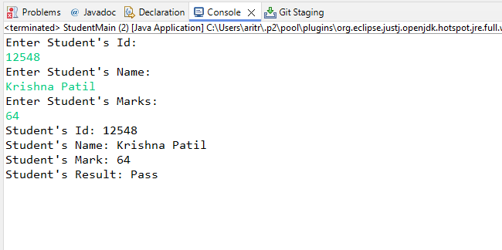

4. Write a Java program that creates a account class with instance variable accno, accname, amount and instance method withdraw, deposit, and interest. Create object of account class test all methods.

public class Account {

    int accNo;  // Variable to store account number

    String accName;  // Variable to store account holder's name

    double amount;  // Variable to store account balance

    // Constructor to initialize the account details

    public Account(int accNo, String accName, double amount) {

        this.accNo = accNo;  // Initialize account number

        this.accName = accName;  // Initialize account holder's name

        this.amount = amount;  // Initialize account balance

    }

    // Method to withdraw an amount from the account

    public void withdraw(double withdrawAmount) {

        // Check if the withdraw amount is valid and sufficient balance is available

        if (withdrawAmount > 0 && withdrawAmount <= amount) {

            amount -= withdrawAmount;  // Deduct the withdraw amount from the balance

            System.out.println("Withdrawal Successful. Remaining Balance: Rs. " + amount);

        } else {

            // Print an error message if the withdraw amount is invalid or insufficient balance

            System.out.println("Withdrawal failed! Insufficient Balance.");

        }

    }

    // Method to deposit an amount into the account

    public void deposit(double depositAmount) {

        // Check if the deposit amount is valid

        if (depositAmount > 0) {

            amount += depositAmount;  // Add the deposit amount to the balance

            System.out.println(depositAmount + " Deposited Successfully! Updated Balance: Rs. " + amount);

        } else {

            // Print an error message if the deposit amount is invalid

            System.out.println("Invalid Amount.");

        }

    }

    // Method to calculate the interest earned on the account balance

    public void calculateInterest(double rate) {

        double interest = (amount * rate) / 100;  // Calculate interest based on the rate

        System.out.println("Interest Earned: " + interest);  // Print the interest earned

    }

}

import java.util.Scanner;  // Import the Scanner class for taking user input

public class BankMain {

    public static void main(String[] args) {

        // Create a Scanner object for input

        Scanner s = new Scanner(System.in);

        // Creating an Account object with initial details

        Account a = new Account(154824, "Aritra", 25000);

        // Prompt and read the amount to withdraw

        System.out.println("Enter Withdrawal amount: Rs. ");

        double withdrawAmount = s.nextDouble();

        // Call the withdraw method to process the withdrawal

        a.withdraw(withdrawAmount);

        // Prompt and read the amount to deposit

        System.out.println("Enter Deposit amount: Rs. ");

        double depositAmount = s.nextDouble();

        // Call the deposit method to process the deposit

        a.deposit(depositAmount);

        // Prompt and read the interest rate

        System.out.println("Enter the rate (%): ");

        double rate = s.nextDouble();

        // Call the calculateInterest method to compute the interest

        a.calculateInterest(rate);

        // Close the Scanner object to prevent resource leaks

        s.close();

    }

}

**Output**

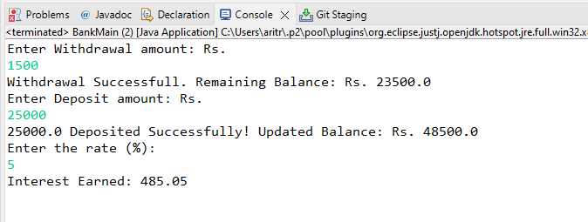

5. Write a Java program to create a class called player with name, age, country Name, total run as instance member. Create 5 player objects and write instance method to display the details of Player having more than 5000 as total run

import java.util.Scanner;  // Import the Scanner class for taking user input

public class Player {

    String name;  // Variable to store player's name

    int age;  // Variable to store player's age

    String countryName;  // Variable to store player's country name

    int totalRun;  // Variable to store player's total runs

    // Method to read player details from user input

    public void readDetails() {

        Scanner s = new Scanner(System.in);  // Create a Scanner object for input

        // Prompt and read player's name

        System.out.println("Enter Player's Name: ");

        name = s.nextLine();

        // Prompt and read player's age

        System.out.println("Enter Player's Age: ");

        age = s.nextInt();

        s.nextLine();  // Consume the newline character left by nextInt()

        // Prompt and read player's country name

        System.out.println("Enter Player's Country Name: ");

        countryName = s.nextLine();

        // Prompt and read player's total runs

        System.out.println("Enter Player's Total Run: ");

        totalRun = s.nextInt();

        s.nextLine();  // Consume the newline character left by nextInt()

    }

    // Method to check if the player's total runs exceed 5000

    public void checkRun() {

        if (totalRun > 5000) {

            dispPlayer();  // Call dispPlayer() method to display player details if total runs exceed 5000

        }

    }

    // Method to display player details

    public void dispPlayer() {

        System.out.println("Player's Name: " + name);  // Display player's name

        System.out.println("Player's Age: " + age);  // Display player's age

        System.out.println("Player's Country Name: " + countryName);  // Display player's country name

        System.out.println("Player's Total Run: " + totalRun);  // Display player's total runs

    }

}

public class PlayerMain {

    public static void main(String[] args) {

        // Create instances of the Player class

        Player p1 = new Player();

        Player p2 = new Player();

        Player p3 = new Player();

        Player p4 = new Player();

        Player p5 = new Player();

        // Read details for each player

        p1.readDetails();

        p2.readDetails();

        p3.readDetails();

        p4.readDetails();

        p5.readDetails();

        // Check runs and display details if applicable for each player

        p1.checkRun();

        p2.checkRun();

        p3.checkRun();

        p4.checkRun();

        p5.checkRun();

    }

}

**Output**

Enter Player's Name:

Virat Kohli

Enter Player's Age:

35

Enter Player's Country Name:

India

Enter Player's Total Run:

8,848

Enter Player's Name:

Rohit Sharma

Enter Player's Age:

37

Enter Player's Country Name:

India

Enter Player's Total Run:

10,709

Enter Player's Name:

Chris Gayle

Enter Player's Age:

44

Enter Player's Country Name:

West Indies

Enter Player's Total Run:

10480

Enter Player's Name:

AB de Villiers

Enter Player's Age:

40

Enter Player's Country Name:

South Africa

Enter Player's Total Run:

9577

Enter Player's Name:

Shubman Gill

Enter Player's Age:

24

Enter Player's Country Name:

India

Enter Player's Total Run:

2271

Player's Name: Virat Kohli

Player's Age: 35

Player's Country Name: India

Enter Player's Total Run: 8848

Player's Name: Rohit Sharma

Player's Age: 37

Player's Country Name: India

Enter Player's Total Run: 10709

Player's Name: Chris Gayle

Player's Age: 44

Player's Country Name: West Indies

Enter Player's Total Run: 10480

Player's Name: AB de Villiers

Player's Age: 40

Player's Country Name: South Africa

Enter Player's Total Run: 9577

Inheritance and Polymorphism (Assignment 2)

### 1. Write java program to implement Inheritance with following example:

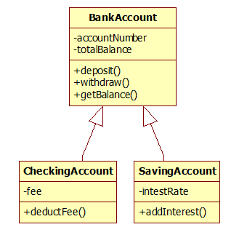

public class BankAccount {

    int accountNumber;  // Variable to store the account number

    double totalBalance;  // Variable to store the total balance

    // Constructor to initialize the account number and total balance

    public BankAccount(int accountNumber, double totalBalance) {

        this.accountNumber = accountNumber;  // Initialize account number

        this.totalBalance = totalBalance;  // Initialize total balance

    }

    // Method to deposit an amount into the account

    public double deposit(double depositAmount) {

        // Check if the deposit amount is greater than zero

        if (depositAmount > 0) {

            totalBalance += depositAmount;  // Add the deposit amount to the total balance

            System.out.println("Rs. " + depositAmount + " Deposited Successfully. Current Balance Rs. " + totalBalance);

        }

        return totalBalance;  // Return the updated balance

    }

    // Method to withdraw an amount from the account

    public double withdraw(double withdrawAmount) {

        // Check if the withdraw amount is greater than zero and does not exceed the total balance

        if (withdrawAmount > 0 && withdrawAmount <= totalBalance) {

            totalBalance -= withdrawAmount;  // Subtract the withdraw amount from the total balance

            System.out.println(withdrawAmount + " Withdrawn Successfully. Current Balance: " + totalBalance);

        } else {

            // Print an error message if the balance is insufficient

            System.out.println("Insufficient Balance.");

        }

        return totalBalance;  // Return the updated balance

    }

    // Method to get the current balance

    public void getBalance() {

        System.out.println("Your Current Balance is: " + totalBalance);  // Print the current balance

    }

}

public class CheckingAccount extends BankAccount {

    double fee; // Variable to store the fee

    // Constructor to initialize the checking account with account number, balance, and fee

    public CheckingAccount(int accountNumber, double totalBalance, double fee) {

        super(accountNumber, totalBalance); // Call the superclass constructor to initialize account number and balance

        this.fee = fee; // Initialize the fee

    }

    // Method to deduct the fee from the account balance

    public void deductFee(double fee) {

        totalBalance -= fee; // Subtract the fee from the total balance

        System.out.println("Total Balance after fees deduction: " + totalBalance); // Display the updated balance

    }

}

public class SavingsAccount extends BankAccount {

    double interestRate; // Variable to store the interest rate

    // Constructor to initialize the savings account with account number, balance, and interest rate

    public SavingsAccount(int accountNumber, double totalBalance, double interestRate) {

        super(accountNumber, totalBalance); // Call the superclass constructor to initialize account number and balance

        this.interestRate = interestRate; // Initialize the interest rate

    }

    // Method to add interest to the account balance

    public double addInterest(double interestRate) {

        // Calculate the total interest earned

        double totalInterest = (totalBalance * interestRate * 1) / 100;

        System.out.println("Interest earned: Rs. " + totalInterest); // Display the interest earned

        // Add the earned interest to the total balance

        totalBalance += totalInterest;

        // Return the updated balance

        return totalBalance;

    }

}

import java.util.Scanner; // Import the Scanner class for taking user input

public class BankMain {

    public static void main(String[] args) {

        int accNo = 0; // Variable to store account number

        double totalBalance; // Variable to store total balance

        double fees = 0; // Variable to store fees

        double interestRate = 0; // Variable to store interest rate

        Scanner s = new Scanner(System.in); // Create a Scanner object for input

        // Prompt and read account details

        System.out.println("Enter the Account Details Below: ");

        System.out.println("Enter Account Number: ");

        accNo = s.nextInt();

        System.out.println("Enter Total Balance: ");

        totalBalance = s.nextDouble();

        // Create a BankAccount object with the provided account number and balance

        BankAccount ba = new BankAccount(accNo, totalBalance);

        // Prompt and read deposit amount, then deposit it into the account

        System.out.println("Enter the amount you want to Deposit: ");

        double depositAmount = s.nextDouble();

        ba.deposit(depositAmount);

        // Prompt and read withdrawal amount, then withdraw it from the account

        System.out.println("Enter the amount you want to Withdraw: ");

        double withdrawAmount = s.nextDouble();

        ba.withdraw(withdrawAmount);

        // Prompt and read fees, then create a CheckingAccount object and deduct the fee

        System.out.println("Enter Fees: ");

        fees = s.nextDouble();

        CheckingAccount ca = new CheckingAccount(accNo, totalBalance, fees);

        ca.deductFee(fees);

        // Prompt and read interest rate, then create a SavingsAccount object and add interest

        System.out.println("Enter Interest Rate: ");

        interestRate = s.nextDouble();

        SavingsAccount sa = new SavingsAccount(accNo, totalBalance, interestRate);

        double interest = sa.addInterest(interestRate);

        // Calculate the total balance after all transactions

        totalBalance = totalBalance + depositAmount - withdrawAmount - fees + interest;

        // Display the current balance

        ba.getBalance();

        s.close(); // Close the Scanner object

    }

}

**Output**

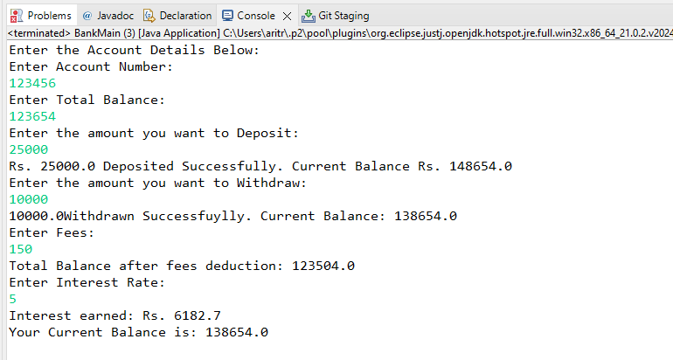

2. Write java program to implement Inheritance with following example: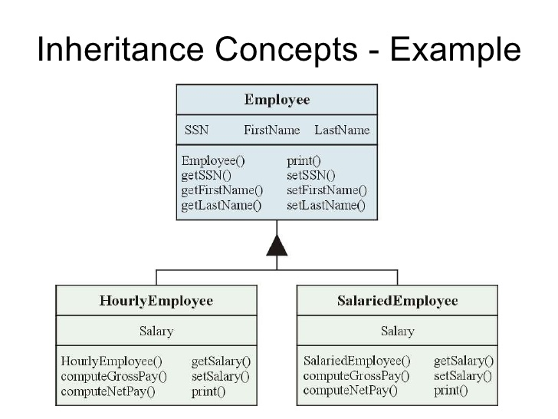

// Base class: Employee

public class Employee {

    // Private fields to store the employee's SSN, first name, and last name

    private String ssn;

    private String firstName;

    private String lastName;

    // Constructor to initialize the employee's SSN, first name, and last name

    public Employee(String ssn, String firstName, String lastName) {

        this.ssn = ssn;

        this.firstName = firstName;

        this.lastName = lastName;

    }

    // Getter method for SSN

    public String getSSN() {

        return ssn;

    }

    // Setter method for SSN

    public void setSSN(String ssn) {

        this.ssn = ssn;

    }

    // Getter method for first name

    public String getFirstName() {

        return firstName;

    }

    // Setter method for first name

    public void setFirstName(String firstName) {

        this.firstName = firstName;

    }

    // Getter method for last name

    public String getLastName() {

        return lastName;

    }

    // Setter method for last name

    public void setLastName(String lastName) {

        this.lastName = lastName;

    }

    // Method to print the employee's information

    public void print() {

        // Print SSN

        System.out.println("SSN: " + ssn);

        // Print first name

        System.out.println("First Name: " + firstName);

        // Print last name

        System.out.println("Last Name: " + lastName);

    }

}

// Subclass: HourlyEmployee extends Employee

public class HourlyEmployee extends Employee {

    // Private field to store the hourly salary

    private double salary;

    // Constructor to initialize HourlyEmployee with ssn, firstName, lastName, and salary

    public HourlyEmployee(String ssn, String firstName, String lastName, double salary) {

        // Call the constructor of the superclass Employee

        super(ssn, firstName, lastName);

        // Initialize the salary field

        this.salary = salary;

    }

    // Getter method for salary

    public double getSalary() {

        return salary;

    }

    // Setter method for salary

    public void setSalary(double salary) {

        this.salary = salary;

    }

    // Method to compute the gross pay based on hours worked

    public double computeGrossPay(int hoursWorked) {

        return salary * hoursWorked;

    }

    // Method to compute the net pay (in this example, it's the same as gross pay)

    public double computeNetPay(int hoursWorked) {

        return computeGrossPay(hoursWorked);

    }

    // Override the print method from the Employee class to include salary

    @Override

    public void print() {

        // Call the print method of the superclass to print SSN, first name, and last name

        super.print();

        // Print the salary

        System.out.println("Salary: " + salary);

    }

}

// Subclass: SalariedEmployee extends Employee

public class SalariedEmployee extends Employee {

    // Private field to store the fixed salary

    private double salary;

    // Constructor to initialize SalariedEmployee with ssn, firstName, lastName, and salary

    public SalariedEmployee(String ssn, String firstName, String lastName, double salary) {

        // Call the constructor of the superclass Employee

        super(ssn, firstName, lastName);

        // Initialize the salary field

        this.salary = salary;

    }

    // Getter method for salary

    public double getSalary() {

        return salary;

    }

    // Setter method for salary

    public void setSalary(double salary) {

        this.salary = salary;

    }

    // Method to compute gross pay (for simplicity, assuming fixed salary)

    public double computeGrossPay() {

        return salary;

    }

    // Method to compute net pay (in this example, it's the same as gross pay)

    public double computeNetPay() {

        return computeGrossPay();

    }

    // Override the print method from the Employee class to include salary

    @Override

    public void print() {

        // Call the print method of the superclass to print SSN, first name, and last name

        super.print();

        // Print the salary

        System.out.println("Salary: " + salary);

    }

}

public class EmployeeMain {

    public static void main(String[] args) {

        // Create an instance of HourlyEmployee with SSN, first name, last name, and hourly salary

        HourlyEmployee hourlyEmployee = new HourlyEmployee("12345", "John", "Doe", 20.0);

        // Create an instance of SalariedEmployee with SSN, first name, last name, and fixed salary

        SalariedEmployee salariedEmployee = new SalariedEmployee("98765", "Jane", "Smith", 5000.0);

        // Display details of the HourlyEmployee

        System.out.println("Hourly Employee Details:");

        hourlyEmployee.print(); // Call print method to display employee details

        System.out.println("Gross Pay: " + hourlyEmployee.computeGrossPay(40)); // Compute and display gross pay for 40 hours

        System.out.println("Net Pay: " + hourlyEmployee.computeNetPay(40)); // Compute and display net pay for 40 hours

        // Display details of the SalariedEmployee

        System.out.println("\nSalaried Employee Details:");

        salariedEmployee.print(); // Call print method to display employee details

        System.out.println("Gross Pay: " + salariedEmployee.computeGrossPay()); // Compute and display gross pay

        System.out.println("Net Pay: " + salariedEmployee.computeNetPay()); // Compute and display net pay

    }

}

**Output**

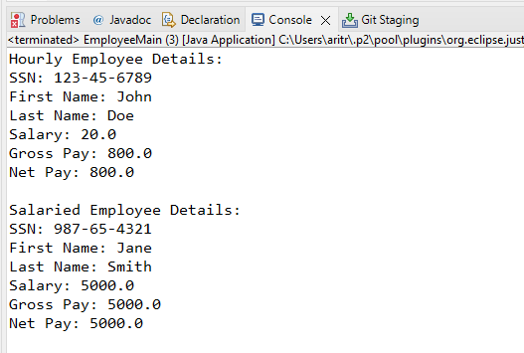

### Write java program to implement Inheritance with following example:

Person will have name and age as data members. Teacher and employee will inherit data members in the super class and create its own method myProfession() to display their profession. Then create objects of Teacher, Permanent, and Contract employee to display their profession..

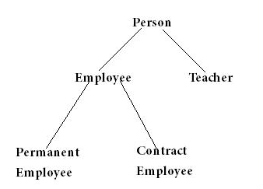

public class Person {

    // Attributes of the Person class

    String name;

    int age;

    // Constructor to initialize the Person object

    public Person(String name, int age) {

        this.name = name; // Set the name of the person

        this.age = age;   // Set the age of the person

    }

    // Method to display the details of the Person

    public void display() {

        System.out.println("Name Of Person: " + name); // Print the person's name

        System.out.println("Age Of Person: " + age);   // Print the person's age

    }

}

//Extending the Person class.

public class Employeee extends Person {

    //Constructor for Employeee objects.

    public Employeee(String name, int age) {

        super(name, age);

    }

    //Prints the profession of the employee.

    public void myProfession() {

        System.out.println(name + " is an Employee.");

    }

}

//Extending the Person class.

public class Teacher extends Person {

    // Constructor for Teacher objects.

    public Teacher(String name, int age) {

        super(name, age);

    }

    //Prints the profession of the teacher.

    public void myProfession() {

        System.out.println(name + " is a Teacher.");

    }

}

//Extending the Employeee class.

public class PermanentEmployee extends Employeee {

    //Constructor for PermanentEmployee objects.

    public PermanentEmployee(String name, int age) {

        super(name, age);

    }

    //Prints the profession of the permanent employee.

    public void myProfession() {

        System.out.println(name + " is a Permanent Employee.");

    }

}

//Extending the Employeee class.

public class ContractEmployee extends Employeee {

    //Constructor for ContractEmployee objects.

    public ContractEmployee(String name, int age) {

        super(name, age);

    }

    //Prints the profession of the contract employee.

    public void myProfession() {

        System.out.println(name + " is a Contract Employee.");

    }

}

**public** **class** PersonMain {

**public** **static** **void** main(String[] args) {

// Creating Objects

Teacher teacher = **new** Teacher("Arvind", 35);

Employeee emp = **new** Employeee("Arun", 37);

PermanentEmployee permanentEmployee = **new** PermanentEmployee("Shubham", 45);

ContractEmployee contractEmployee = **new** ContractEmployee("Ritik", 34);

// Calling the methods

teacher.myProfession();

emp.myProfession();

permanentEmployee.myProfession();

contractEmployee.myProfession();

}

}

**Output**

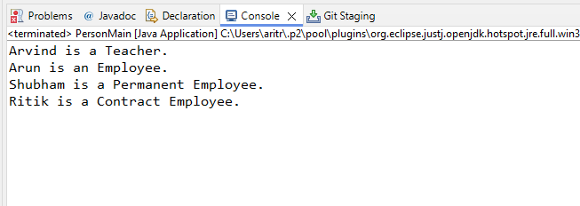

1. **Inheritance Using has a Relationship**

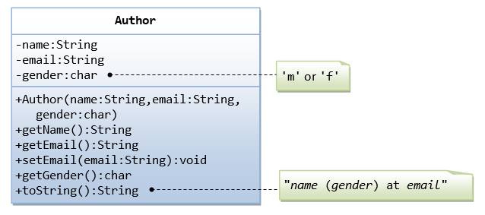

A class called Author is designed as shown in the class diagram. It contains:

* Three private member variables: name (String), email (String), and gender (char of either 'm' or 'f' - you might also use a boolean variable called isMale having value of true or false).
* A constructor to initialize the name, email and gender with the given values.  
  (There is no *default constructor*, as there is no default value for name, email and gender.)
* Public getters/setters: getName(), getEmail(), setEmail(), and getGender().  
  (There are no setters for name and gender, as these properties are not designed to be changed.)

**A Book is written by one Author - Using an "Object" Member Variable**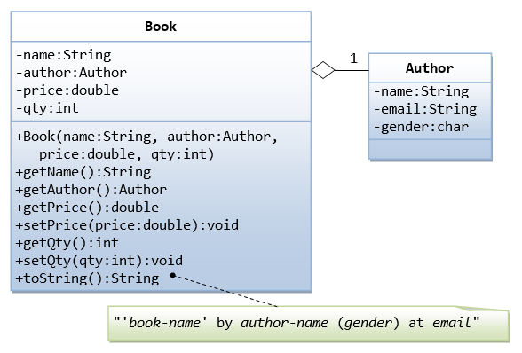

Let's design a Book class. Assume that a book is written by one (and exactly one) author. The Book class (as shown in the class diagram) contains the following members:

* Four private member variables: name (String), author (an *instance* of the Author class we have just created, assuming that each book has exactly one author), price (double), and qty (int).
* The public getters and setters: getName(), getAuthor(), getPrice(), setPrice(), getQty(), setQty().

// Author class representing an author of a book

public class Author {

    // Private member variables to store author's information

    private String name;

    private String email;

    private char gender;

    // Constructor to initialize the name, email, and gender of the author

    public Author(String name, String email, char gender) {

        this.name = name;

        this.email = email;

        this.gender = gender;

    }

    // Getter method to retrieve the name of the author

    public String getName() {

        return name;

    }

    // Getter method to retrieve the email of the author

    public String getEmail() {

        return email;

    }

    // Getter method to retrieve the gender of the author

    public char getGender() {

        return gender;

    }

}

// Book class representing a book written by an author

public class Book {

    // Private member variables to store book information

    private String name;

    private Author author;

    private double price;

    private int qty;

    // Constructor to initialize the name, author, price, and quantity of the book

    public Book(String name, Author author, double price, int qty) {

        this.name = name;

        this.author = author;

        this.price = price;

        this.qty = qty;

    }

    // Getter method to retrieve the name of the book

    public String getName() {

        return name;

    }

    // Getter method to retrieve the author of the book

    public Author getAuthor() {

        return author;

    }

    // Getter method to retrieve the price of the book

    public double getPrice() {

        return price;

    }

    // Setter method to set the price of the book

    public void setPrice(double price) {

        this.price = price;

    }

    // Getter method to retrieve the quantity of the book

    public int getQty() {

        return qty;

    }

    // Setter method to set the quantity of the book

    public void setQty(int qty) {

        this.qty = qty;

    }

}

public class AuthorMain {

    public static void main(String[] args) {

        // Create an author

        Author author = new Author("John Doe", "john@example.com", 'm');

        // Create a book

        Book book = new Book("Java Programming", author, 560, 100);

        // Display book information

        System.out.println("Book Name: " + book.getName());

        System.out.println("Author Name: " + book.getAuthor().getName());

        System.out.println("Author Email: " + book.getAuthor().getEmail());

        System.out.println("Author Gender: " + book.getAuthor().getGender());

        System.out.println("Price: Rs" + book.getPrice());

        System.out.println("Quantity Available: " + book.getQty());

        // Update book price and quantity

        book.setPrice(630);

        book.setQty(50);

        // Display updated book information

        System.out.println("\nUpdated Price: Rs" + book.getPrice());

        System.out.println("Updated Quantity Available: " + book.getQty());

    }

}

**Output**

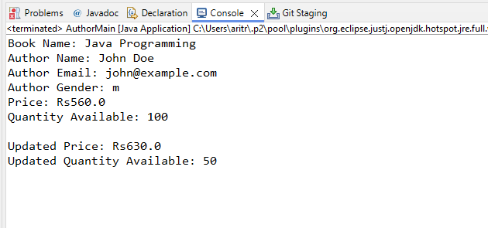

1. Write java program to implement Polymorphism with following example

a)

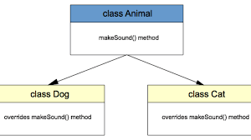

// Animal class representing a generic animal

public class Animal {

    // Method to make a generic animal sound

    public void makeSound() {

        System.out.println("Generic animal sound!");

    }

}

// Dog class representing a specific type of animal - a dog

public class Dog extends Animal {

    // Override the makeSound() method from the Animal class

    @Override

    public void makeSound() {

        System.out.println("Woof!");

    }

}

public class AnimalMain {

    public static void main(String[] args) {

        // Create an instance of Animal

        Animal animals = new Animal();

        // Create instances of Dog and Cat

        Dog d = new Dog();

        Cat c = new Cat();

        // Make sounds of the animals

        System.out.println("Sound of generic animal:");

        animals.makeSound(); // Invoke makeSound() of Animal class

        System.out.println("\nSound of a dog:");

        d.makeSound(); // Invoke overridden makeSound() of Dog class

        System.out.println("\nSound of a cat:");

        c.makeSound(); // Invoke overridden makeSound() of Cat class

    }

}

**Output**

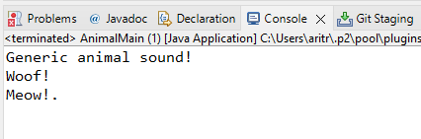

b)

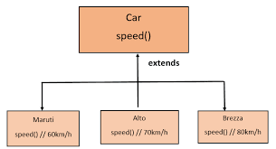

// Car class representing a generic car

public class Car {

    // Method to represent a generic speed of a car

    public void speed() {

        System.out.println("Car Generic Speed.");

    }

}

// Maruti class representing a specific type of car - a Maruti

public class Maruti extends Car {

    // Override the speed() method from the Car class

    @Override

    public void speed() {

        System.out.println("Maruti's Speed is 60 km/h.");

    }

}

// Alto class representing a specific type of car - an Alto

public class Alto extends Car {

    // Override the speed() method from the Car class

    @Override

    public void speed() {

        System.out.println("Alto's Speed is 70 km/h.");

    }

}

// Brezza class representing a specific type of car - a Brezza

public class Brezza extends Car {

    // Override the speed() method from the Car class

    @Override

    public void speed() {

        System.out.println("Brezza's Speed is 80 km/h.");

    }

}

// Main class to test polymorphism with Car, Maruti, Alto, and Brezza classes

public class CarMain {

    public static void main(String[] args) {

        // Create an instance of Car

        Car c = new Car();

        // Create instances of Maruti, Alto, and Brezza

        Maruti m = new Maruti();

        Alto a = new Alto();

        Brezza b = new Brezza();

        // Invoke the speed() method of each object

        System.out.println("Generic Car Speed:");

        c.speed(); // Invoke speed() of Car class

        System.out.println("\nMaruti's Speed:");

        m.speed(); // Invoke overridden speed() of Maruti class

        System.out.println("\nAlto's Speed:");

        a.speed(); // Invoke overridden speed() of Alto class

        System.out.println("\nBrezza's Speed:");

        b.speed(); // Invoke overridden speed() of Brezza class

    }

}

**Output**

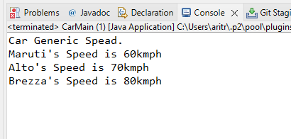

c)

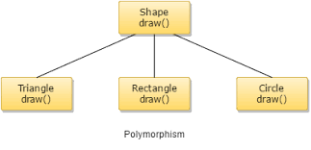

// Shape class representing a generic shape

public class Shape {

    // Method to represent drawing a generic shape

    public void draw() {

        System.out.println("This is a generic shape.");

    }

}

// Triangle class representing a specific type of shape - a triangle

public class Triangle extends Shape {

    // Override the draw() method from the Shape class

    @Override

    public void draw() {

        System.out.println("This is a triangle.");

    }

}

// Rectangle class representing a specific type of shape - a rectangle

public class Rectangle extends Shape {

    // Override the draw() method from the Shape class

    @Override

    public void draw() {

        System.out.println("This is a rectangle.");

    }

}

// Circle class representing a specific type of shape - a circle

public class Circle extends Shape {

    // Override the draw() method from the Shape class

    @Override

    public void draw() {

        System.out.println("This is a circle.");

    }

}

// Main class to test polymorphism with Shape, Triangle, Rectangle, and Circle classes

public class ShapeMain extends Shape {

    public static void main(String[] args) {

        // Create instances of Shape, Triangle, Rectangle, and Circle

        Shape s = new Shape();

        Triangle t = new Triangle();

        Rectangle r = new Rectangle();

        Circle c = new Circle();

        // Invoke the draw() method of each object

        System.out.println("Drawing a generic shape:");

        s.draw(); // Invoke draw() of Shape class

        System.out.println("\nDrawing a triangle:");

        t.draw(); // Invoke overridden draw() of Triangle class

        System.out.println("\nDrawing a rectangle:");

        r.draw(); // Invoke overridden draw() of Rectangle class

        System.out.println("\nDrawing a circle:");

        c.draw(); // Invoke overridden draw() of Circle class

    }

}

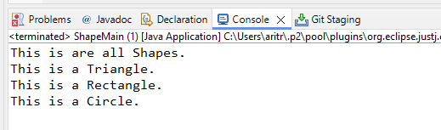

d)

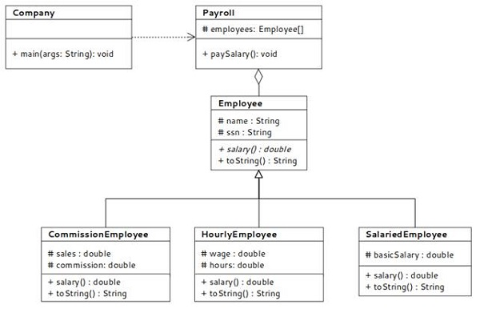

public class Employee1 {

    // Protected attributes for name and SSN, accessible within the class and

    // subclasses

    protected String name;

    protected String ssn;

    // Constructor to initialize the Employee1 object

    public Employee1(String name, String ssn) {

        this.name = name; // Set the name of the employee

        this.ssn = ssn; // Set the SSN of the employee

    }

    // Method to return the salary of the employee

    public double salary() {

        return 20000.00; // Default salary

    }

    // Override the toString method to provide a string representation of the

    // Employee1 object

    @Override

    public String toString() {

        return "Name: " + name + ", SSN: " + ssn + ", Salary: " + salary();

    }

}

public class CommissionEmployee extends Employee1 {

    // Private attributes for sales and commission rate

    private double sales;

    private double commission;

    // Constructor to initialize the CommissionEmployee object

    public CommissionEmployee(String name, String ssn, double sales, double commission) {

        super(name, ssn); // Call the constructor of the superclass Employee1

        this.sales = sales; // Set the sales amount

        this.commission = commission; // Set the commission rate

    }

    // Override the salary method to calculate the salary based on sales and

    // commission

    @Override

    public double salary() {

        return sales * commission; // Calculate salary as sales multiplied by commission rate

    }

    // Override the toString method to provide a string representation of the

    // CommissionEmployee object

    @Override

    public String toString() {

        return super.toString() + ", Sales: " + sales + ", Commission: " + commission;

    }

}

public class HourlyEmployee1 extends Employee1 {

    // Private attributes for wage and hours worked

    private double wage;

    private double hours;

    // Constructor to initialize the HourlyEmployee1 object

    public HourlyEmployee1(String name, String ssn, double wage, double hours) {

        super(name, ssn); // Call the constructor of the superclass Employee1

        this.wage = wage; // Set the hourly wage

        this.hours = hours; // Set the number of hours worked

    }

    // Override the salary method to calculate the salary based on wage and hours worked

    @Override

    public double salary() {

        return wage * hours; // Calculate salary as wage multiplied by hours worked

    }

    // Override the toString method to provide a string representation of the HourlyEmployee1 object

    @Override

    public String toString() {

        return super.toString() + ", Wage: " + wage + ", Hours: " + hours;

    }

}

public class SalariedEmployee1 extends Employee1 {

    // Private attribute for basic salary

    private double basicSalary;

    // Constructor to initialize the SalariedEmployee1 object

    public SalariedEmployee1(String name, String ssn, double basicSalary) {

        super(name, ssn); // Call the constructor of the superclass Employee1

        this.basicSalary = basicSalary; // Set the basic salary

    }

    // Override the salary method to return the basic salary

    @Override

    public double salary() {

        return basicSalary; // Return the basic salary

    }

    // Override the toString method to provide a string representation of the SalariedEmployee1 object

    @Override

    public String toString() {

        return super.toString() + ", Basic Salary: " + basicSalary;

    }

}

import java.util.ArrayList;

public class Payroll {

    // Private attribute to store a list of employees

    private ArrayList<Employee1> employees;

    // Constructor to initialize the Payroll object

    public Payroll() {

        this.employees = new ArrayList<>(); // Initialize the ArrayList of employees

    }

    // Method to add an employee to the payroll

    public void addEmployee(Employee1 employee) {

        employees.add(employee); // Add the provided employee to the list

    }

    // Method to pay salary to all employees and print their details

    public void paySalary() {

        for (Employee1 employee : employees) { // Iterate through each employee in the list

            System.out.println(employee); // Print the details of the employee, including the computed salary

        }

    }

}

public class Company {

    public static void main(String[] args) {

        // Create a Payroll object to manage employee salaries

        Payroll payroll = new Payroll();

        // Add different types of employees to the payroll

        payroll.addEmployee(new CommissionEmployee("Akash Rauth", "785496", 5000, 0.10));

        payroll.addEmployee(new HourlyEmployee1("Juli Sinha", "263548", 20, 40));

        payroll.addEmployee(new SalariedEmployee1("Ritu Raj", "32548", 60000));

        // Pay salary to all employees and print their details

        payroll.paySalary();

    }

}

**Output**

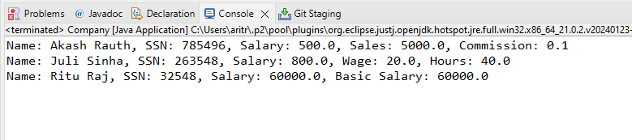

1. Write java program to implement interface with following example

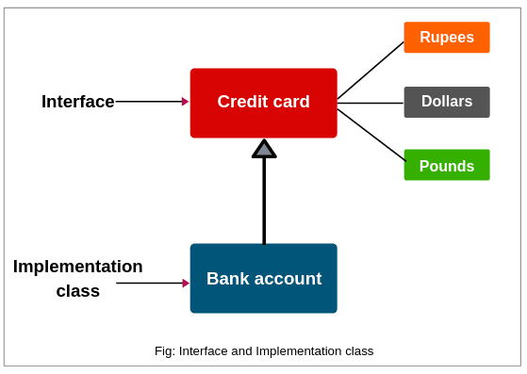

// Interface representing a credit card with methods for making payments in different currencies

public interface CreditCard {

    // Method to make payment in Rupees

    void rupees(float amount);

    // Method to make payment in Dollars

    void dollar(float amount);

    // Method to make payment in Pounds

    void pound(float amount);

}

// Class implementing the CreditCard interface

class Bank implements CreditCard {

    // Method implementation for making payment in Rupees

    @Override

    public void rupees(float amount) {

        System.out.println(amount + " paid in Rupees");

    }

    // Method implementation for making payment in Dollars

    @Override

    public void dollar(float amount) {

        System.out.println(amount + " paid in Dollar");

    }

    // Method implementation for making payment in Pounds

    @Override

    public void pound(float amount) {

        System.out.println(amount + " paid in Pound");

    }

}

import java.util.Scanner;

// Main class to facilitate transactions using Bank class

public class BankAccountMain {

    public static void main(String[] args) {

        Scanner sc = new Scanner(System.in);

        // Prompt user to enter the amount to transact

        System.out.println("Enter the amount you want to transact: ");

        float amount = sc.nextFloat();

        // Display options for currency selection

        System.out.println("Choose an option from below: ");

        System.out.println("Press 1: From Rupees. ");

        System.out.println("Press 2: From Dollar. ");

        System.out.println("Press 3: From Pound. ");

        System.out.println("Press 4: Exit");

        // Create a reference variable of type CreditCard

        CreditCard c;

        // Read user's choice

        int choice = sc.nextInt();

        switch (choice) {

            case 1:

                c = new Bank();

                c.rupees(amount); // Make payment in Rupees

                break;

            case 2:

                c = new Bank();

                c.dollar(amount); // Make payment in Dollars

                break;

            case 3:

                c = new Bank();

                c.pound(amount); // Make payment in Pounds

                break;

            case 4:

                System.out.println("Thanks for using.");

                break;

            default:

                System.out.println("Invalid Option! Try Again");

        }

        sc.close(); // Close the scanner

    }

}

**Output**

